LECTURE 3.1.4
GRAPHS
Course outcome to be covered:
CO3: Apply and recognized about the Graph Theory

1.1 DIFFERENT TYPES OF GRAPHS
In this lecture we will study about different types of graphs like connected graphs, simple, multi, pseudo, regular and bipartite graphs.
1.2 TOPIC OBJECTIVES
- The students will learn different types of graphs and their properties which will make the concept of graphs more clear.
- This topic will help to develop an understanding of the fundamentals of the field of graphs.
1.3 STRUCTURE:
- Introduction
- Different types of graphs
- Connected graph
- Simple graph
- Multi graph
- Pseudo graph
- Regular graph
- Bipartite graph
1.4 INTRODUCTION
In this lecture we study about different types of graphs with definitions, properties and examples. The graphs such as connected graph, complete graph, simple graph, multi graph, pseudo graph, regular graph and bipartite graphs will be discussed.
  - Connected graph
A graph is called connected if there is a path between any vertex u to any other vertex v of graph or vice versa. The graphs shown below in fig 1 are all connected graphs.
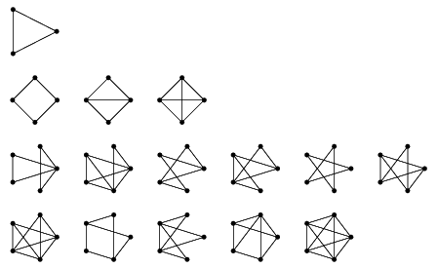
Fig 1
1.6Disconnected graphs
A graph is called disconnected if there is no path between any two of its vertices. The graph below in fig 2 is an example of disconnected graph.
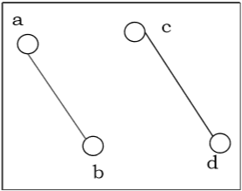Fig 2
1.7Connected Component
A sub graph of graph G is called the connected component of G, if it is not contained in any bigger sub graph of G, which is connected. It is defined by listing its vertices.
Example: Consider the graph shown in fig 3 below. Determine its connected components.
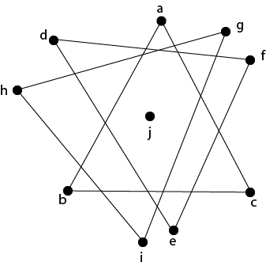Fig 3
Solution: The connected components of this graph is {a, b, c}, {d, e, f}, {g, h, i} and {j}.

1.8Null Graphs
Definition: A graph G= (V(G),E(G)) is a Null Graph if there are no edges in the graph, that is ∣E(G)∣=0.
Null graphs are denoted as Nn where n denotes the number of vertices of the graph. Below are some examples of null graphs, namely N2, N3, and N4, in fig 4
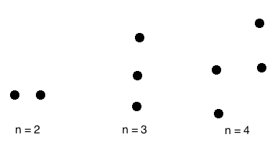Fig 4
We should note that null graphs always have degree 0 since there are no edges joining the vertices. Null graphs also have 0 edges clearly. We can say that null graphs are also 0-regular.

1.9Simple graph
A simple graph is one for which there is no more one edge directed from any one vertex to any other vertex. Below fig 5 is an example of simple graph.
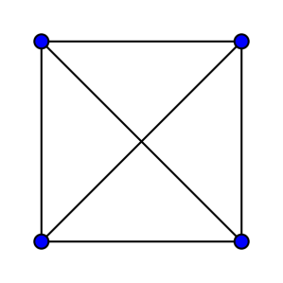Fig 5
1.10Multi graphs
If in a graph multiple edges between the same set of vertices are allowed, it is known as Multi graph. In other words, it is a graph having at least one loop or multiple edges. See fig 6
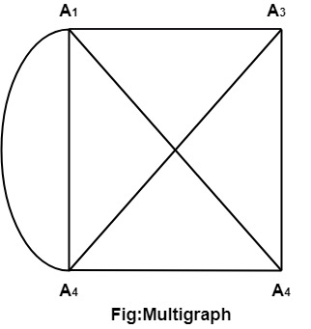Fig 6
1.11 Pseudo graph
A pseudo graph is a non-simple graph in which both graph loops and multiple edges are permitted. See below fig 7 for as example:
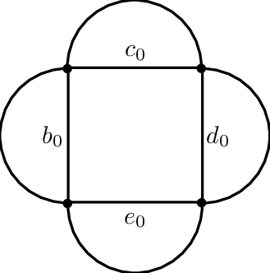Fig 7
1.12 Directed Graphs
A directed graph or digraph G is defined as an unordered pair (V, E), where V is the set of points called vertices and E is the set of edges. Each edge in the graph G is assigned a direction and is identified with an ordered pair (u, v), where u is the initial vertex, and v is the end vertex.
Example: Consider the directed graph G = (V, E) as shown in fig 8. Determine the vertex set and edge set of graph G.
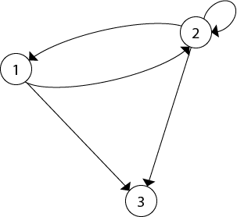Fig 8
Solution: The vertex and edge set of graph G =(V, E) is as follow
G={{1,2,3},{(1,2),(2,1),(2,2),(2,3),(1,3)}}.
1.13Undirected Complete Graph
An undirected complete graph G=(V,E) of n vertices is a graph in which each vertex is connected to every other vertex i.e, and edge exist between every pair of distinct vertices. It is denoted by K_{n}.A complete graph with n vertices will have 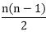edges.
Example: Draw Undirected Complete Graphs K₄ and K₆.
Solution: The undirected complete graph of k₄ and that of k₆ is shown in fig9 below.
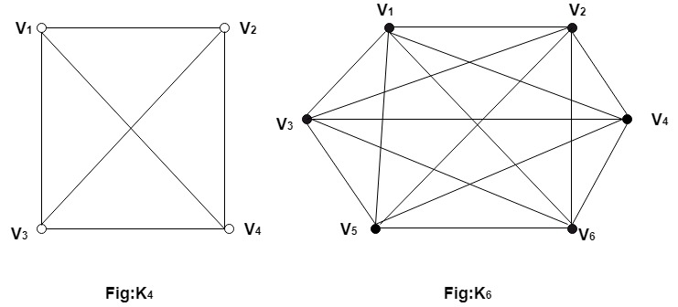Fig 9
1.14Regular graph
A regular graph is a graph where each vertex has the same number of neighbors; i.e. every vertex has the same degree or valency. A regular directed graph must also satisfy the stronger condition that the in degree and out degree of each vertex are equal to each other. A regular graph with vertices of degree k is called a k regular graph or regular graph of degree k.
Example: Draw 2 regular and 3 regular graphs with 8 vertices.
Solution: Below fig 10 represents the 2 and 3 regular graphs with 8 vertices.
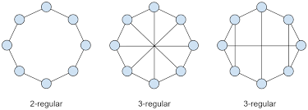Fig 10
1.15Bipartite Graph
If the vertex-set of a graph G can be split into two disjoint sets, V₁ and V₂ , in such a way that each edge in the graph joins a vertex in V₁ to a vertex in V₂ , and there are no edges in G that connect two vertices in V₁ or two vertices in V₂ , then the graph G is called a bipartite graph. See the example below in fig 11
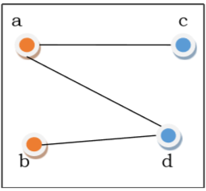Fig 11
1.16Complete Bipartite Graph
A complete bipartite graph is a bipartite graph in which each vertex in the first set is joined to every single vertex in the second set. The complete bipartite graph is denoted by K_{x,y} where the graph G contains x vertices in the first set and y vertices in the second set. Below fig 12 is the example of K_{3,4}
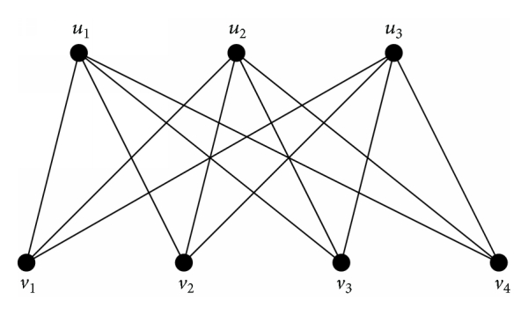K_{3,4}
Fig 12

SUMMARY
The topics discussed in today’s lecture are summarized below:
- If there exist a path between every two vertices of a graph, then it is called a connected graph. Otherwise disconnected.
- A graph having no edge is called a null graph.
- A graph which has neither loops nor multiple edges i.e. where each edge connects two distinct vertices and no two edges connects the same pair of vertices is called a simple graph.
- Any graph which contains some multiple edges is called a multi graph. In a multi graph, no loops are allowed.
- A graph in which loops and multiple edges are allowed is called pseudo graph.
- If each edge in the graph G is assigned a direction then it is a directed graph otherwise undirected graph.
- A graph where each vertex has the same number of neighbors is called regular graph.

Frequently asked questions
Q1 how do you prove a graph is bipartite?
Ans A graph is bipartite iff its vertices can be divided into two sets, such that every edge connects a vertex from set 1 to one in set 2. You already have such a division: each edge connects a vertex from the set of odd-degree vertices, to a vertex in the set of even-degree vertices.

Q2 what is the difference between multi graph and pseudo graph?
Ans the differentiating factor is that a multi graph may not have loops, only self-edges. While pseudo graph can have both.
REFERENCES

WEB LINKS

1 https://sites.google.com/a/cs.christuniversity.in/discrete-mathematics-lectures/types-of-graphs

- https://www.slideshare.net/AdilAslam4/chapter-10-graphs-in-discrete-mathematics

VIDEO LINKS
1 https://youtu.be/mwPvcyRC4_Y

- https://youtu.be/StJCx7u0PIw

Applications

The different types of graphs can be used in research areas of computer science such as data mining, image segmentation, clustering, image capturing, networking etc.
It is ultimately the study of relationships. Given a set of nodes & connections, which can abstract anything from city layouts to computer data, graph theory provides a helpful tool to quantify & simplify the many moving parts of dynamic systems.

Practice questions

Q1 Draw the undirected graphs K₃ and K₅ .
Q2 Draw the bipartite graph K_{2,4} .

